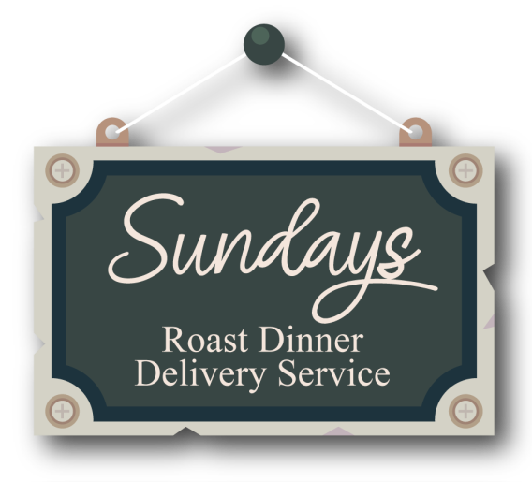

Sundays Roast Dinner Allergen Information
Starters

Soup of the Day WHEAT, MILK
Crispy Coated Garlic Breaded Mushrooms WHEAT
Classic Prawn Cocktail EGGS, MILK, CRUSTACEANS
Bread Roll WHEAT, OATS, EGG, SOYA
Butter MILK
Mains
Roast Beef Dinner WHEAT, MILK, EGG, MUSTARD
Roast Lamb Dinner WHEAT, MILK, EGG, MUSTARD
Roast ½ Chicken Dinner WHEAT, MILK, EGG, MUSTARD
Cajun Sweet Potato Roulade (Vegan & GF) SOYABEAN, MUSTARD (made in a factory contatining nuts and milk. Not suitable for lactose intolerant or but allergies)
Vegetarian Nut roast WHEAT, EGG, PEANUTS, NUTS, SESAME
Extras Cauliflower Cheese MILK,MUSTARD
Honey Roasted Parsnips N/A
Pork Chipolatas SULPHITES
Yorkshire Pudding EGG, WHEAT, MILK
Gravy WHEAT, MUSTARD
Roast Potatoes N/A
Sage & Onion Stuffing WHEAT
Mashed Potatoes MILK

Desserts £3.95
Chocolate Fudge Fixation WHEAT, MILK, EGGS, GLUTEN, NUTS
Hazelnut & Praline Crunchball Cheesecake MILK, EGGS, WHEAT, GLUTEN, NUTS, SOYA, SULPHITES
Key Lime Pie MILK, EGGS, WHEAT, NUTS, PEANUTS, SOYA
Gluten Free Apple & Blackcurrant Crumble Cheesecake MILK, EGGS, NUTS
Vegan Chocolate Cake WHEAT, NUTS
Sticky Toffee Pudding MILK, EGGS, WHEAT possibly also contains nuts, peanuts, sulphites & soya
Classic Bread & Butter Pudding MILK, EGGS, WHEAT, SOYA possibly also contains nuts, peanuts
Sauces
Bramley Apple N/A
Cranberry N/A
Mint SULPHITES
English Mustard MUSTARD
Drinks
Coke, Diet Coke & Fanta Cans N/A

