Christmas Party Menu A 8.50 pp
A Selection of Mini Rolls, Sliced Bloomers & Wraps, Filled with a Selection of Festive Fillings, to include;
French Brie & Grape, Gammon Ham & Apple Chutney, Turkey, Cranberry & Chestnut Stuffing, Fresh Prawns and Avocado, Smoked Salmon, Capers and Lemon Mayo, Coronation Chicken
Whiskey Glazed Pork Belly Squares with Sour Cream & Chive Dip
Filo Wrapped King Prawns
Luxury Samosas, Pakoras & Onion Bhajis with a Tikka Dip (V)
Fig and Goats Cheese Parcels (V)

Chocolate Yule Log / Deep Viennese Mince Pies

Christmas Menu B 10.50 pp
A Selection of Sour Dough and Rye Breads Made With Festive Fillings to include:
French Brie & Grape, Gammon Ham & Apple Chutney, Turkey, Cranberry & Chestnut Stuffing, Fresh Prawns and Avocado, Smoked Salmon, Capers and Lemon Mayo, Coronation Chicken
Sweet Chilli Steak skewers
Salt & Pepper Squid with Garlic Aioli
Tempura Torpedo Prawns
Butternut Squash, Rocket & Goats Cheese Tarts(V)
Crispy Brie Filled Wedges(V)
Spiced Falafel Balls (V)
Individual Chocolate Praline Truffle Sponges Chocolate praline truffle mouse surrounded by nut sponge topped with chocolate ganache, amaretti crumb and a chocolate decoration.
Individual Irish Cream Liqueur Cheesecakes Digestive base topped with fresh cream Irish liqueur cheesecake mousse and caramel sauce.

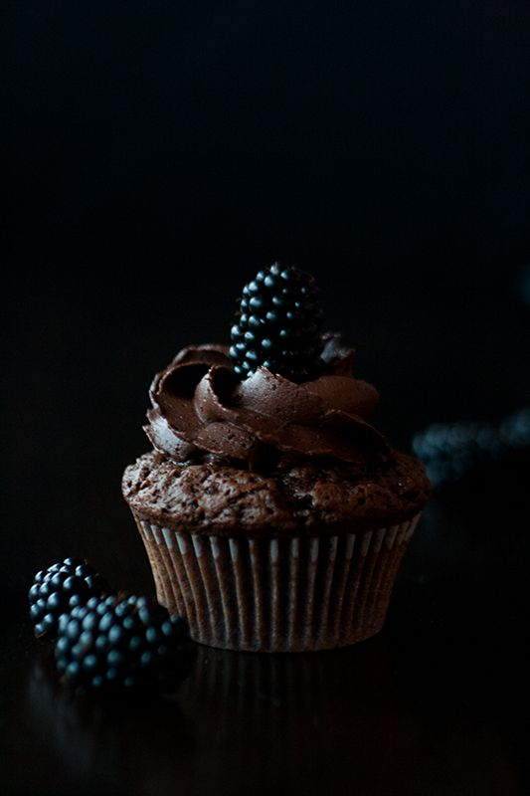
Christmas Party Menu C £17.00pp
Sliced Turkey Crown
Sliced Orange & Clove Ham
Chicken Liver, Clementine & Wild Mushroom Terrine
A Selection of Sliced Breads, Crackers and Chutneys
Luxury Cheeseboard with Chutneys & Pickles
Goats Cheese & Red Onion Tarts (V)
Individual Chicken & Mushroom Pies
Sweet Potato Wedges Baked with Rosemary and Thyme and Served with a Sour Cream Dip (V)
Rum & Black Cherry Roulade Moist chocolate sponge enriched with dark rum, layered with jam and fresh cream, marbled with black cherries and decorated with chocolate ganache and white chocolate shavings
Fred and Ginger Cheesecake Vanilla cheesecake with chunks of ginger sponge topped with smaller gingerbread chunks and drizzled with toffee sauce.

Finger Food Additions £1.00 per item
Mini Sausages Wrapped in Bacon, Sweet Potato Wedges with Tomato Chutney (V), Chicken Satay Sticks, Lime & Ginger Fishcakes, Prawn Dimsums, Chinese Wontons, Prawn Toast, Luxury Samosas(V)
Onion Bhajis (V), Chicken Pakoras, Luxury Scotch Eggs, Spanish Tortilla Wedges (V), Tempura Prawns, Tandoori Chicken Bites with Yoghurt and Mint Dip, Mixed Kalamata Olives (V), Roasted Red Peppers(V), Luxury Chicken Pakoras, Feta & Olive Sticks (V), Spiced Falafel Balls (V) Cheese and Bacon Potato Skins, Mediterranean Pizza Slices(V), Bbq Chicken Pizza Slices, Southern Fried Chicken & Jack Daniels Bbq Sauce, Hot & Spicy Chicken Wings

Charcuterie Board £26.00 (Serves 10 people)
Pate, Prosciutto, Dry Cured Salami, Sundried Tomatoes, Grapes, Cornichons, Chutney, Gouda Cheese, Brie & Dried Figs. Accompanied with a variety of crackers and sliced breads.
Luxury Cheeseboard £28.50 (Serves 10 people)
An array of Soft and Hard Cheeses, Pickles, Fruit, Nuts, Crackers & Breads

Salad Bowls £15.00 each (Each bowl serves 10 people)

New Potato & Herb Salad New Potatoes, Chopped Herbs & Butter
Greek Salad Fresh Mixed Leaf, Cherry Tomatoes, Cucumber, Red Onions, Feta & Olives
Waldorf Salad Slices of Red Apple, Celery, Walnuts & Grapes
Traditional Coleslaw Shredded Cabbage, Carrots and Onion in a Creamy Mayonnaise
Jewelled Cous Cous Plump Cous Cous, Roasted Vegetables, Mint, Coriander
Italian Pasta Salad Pasta Spirals, Baby Tomatoes, Rocket, Olives, Herb Dressing

