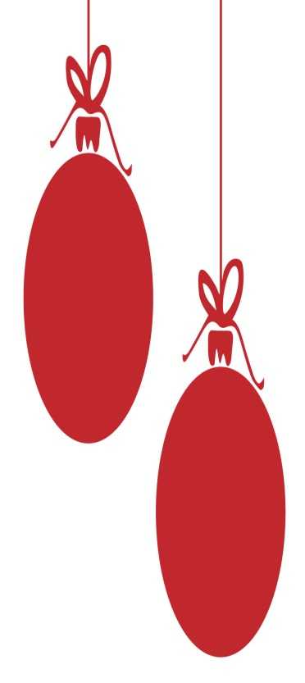
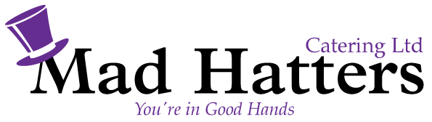
Christmas Hot Buffet £17.50 pp
Served from a Buffet Table with a Chef and Staff to serve

Starters
Roasted Butternut Squash Soup with Bread Roll & Butter

Main Course
Choice of Butter Roasted Turkey or Roast Beef
Roast Potatoes, Parsnips, Glazed Carrots, Sprouts, Pig in Blankets, Yorkshire Pudding & Stuffing
Gravy
Choice of Sauces
Vegetarian options available

Dessert
Christmas Pudding with Hot Custard
Black Forrest Gateaux

Freshly Brewed Coffee & Tea with Chocolate Truffles

Prices are exclusive of VAT
Minimum numbers are 30 x people
This buffet is supplied with Chef, Staff , Crockery & Cutlery.

