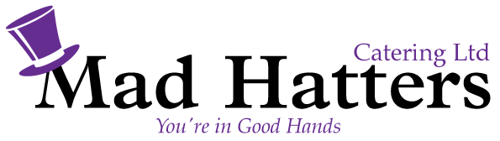
Hot Fork and Knife Buffet £18.00 (Inclusive vat)
Minimum of 20 people

Orange, Honey and Clove Baked Ham
Slow Roasted Peppered Topside of Beef
Mediterranean Tart, Filled with Roasted Vegetables
Individual Pork Sausages, Dressed in Honey & Wholegrain Mustard
Assorted Buttered Vegetables
Hot New Potatoes with Chive Butter
……………………………………………………
Chocolate Fudge Cake and Double Cream
Caramel Carrot Cake

Price includes Crockery, Cutlery, Hot Holding Equipment & vat

