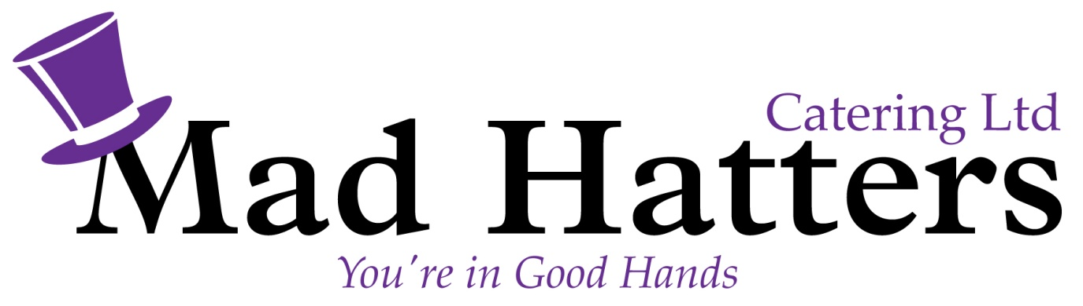

Sample Chefs to Home Menu £38.50pp (inclusive of vat)

Option One
Smoked Salmon & Prawn Terrine Served with a Side Salad and Rye Bread
Green Bean, Tomato & Artichoke Salad (V)
………………………………..
Slow Cooked Lamb Shank Served with Red Wine Jus, mustard mash & Seasonal Vegetables
Asparagus, Mushroom and Parmesan Risotto (V)
……………………………………….
Strawberry Cheesecake
Dark Chocolate and Cream Pots

Option 2
Marinated Lamb Skewers with a Red Pepper and Mango Lime Salsa
Goats Cheese & Caramelised Onion Tartlet Served with a Side Salad (V)
………………………..
Fillet Mignon with Balsamic Onion Marmalada, Dauphenoise Potatoes & Seasonal Vegetables
Warm Apple Tart & Clotted Cream Ice Cream
Selection of Cheeses, Oatcakes & Crackers

Option 3

Broad Bean and Mint Panzanella with Mozzarella (v)

Prosciutto-wrapped scallops with lemon and parsley butter
……………………
Roasted Pork Belly with Cauliflower, Apples and Greens
Tomato & Caper Linguine (V)
………………………
Sticky Toffee Pudding & Caramel Sauce
Crème Brûlée & Sable Biscuit

Price includes Crockery, Cutlery, Hot Holding Equipment & vat

