Refreshments
Freshly Brewed Coffee & Tea Includes hot holding equipment, Cup, Saucers, teaspoons, Sugars, Sweeteners & Milk
£1.25 per person
Biscuit Assortments 3 per person
£0.70 per person
Cake Slices
£0.70 per person
Welsh Cakes
£0.70 per person
Fruit Juice Choice of Apple, Orange or Cranberry
£2.00 per litre carton
500ml Bottled Water Still or Sparkling
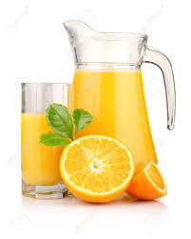
0.70 per bottle
1.5 litre Bottled Water Still or Sparkling
£2.00 per bottle

