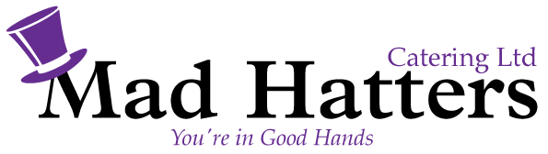

Hot Fork and Knife Buffet £14.95 pp exc vat
Minimum of 20 people

Orange, Honey and Clove Baked Ham
Slow Roasted Peppered Topside of Beef
Broccoli & Cheese Quiche
Individual Pork Sausages, Dressed in Honey & Wholegrain Mustard
Assorted Buttered Vegetables
Hot New Potatoes with Chive Butter
……………………………………………………
Chocolate Fudge Cake and Double Cream

Price include Crockery, Cutlery and Hot Holding Equipment

