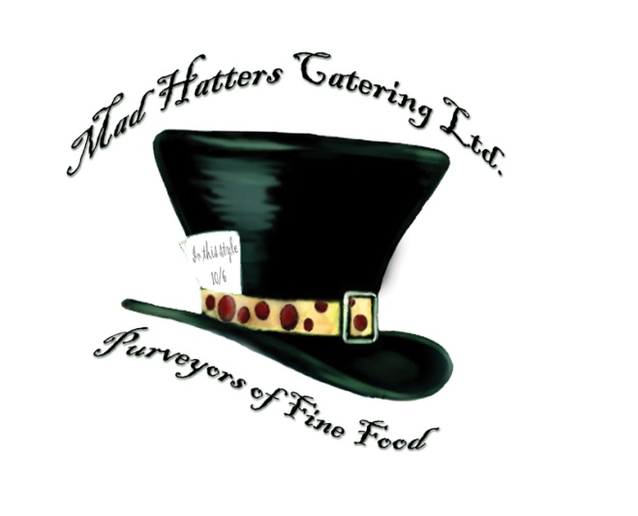
Hot Fork and Knife Buffet £12 pp exc vat
Minimum of 20 people

Orange, Honey and Clove Baked Ham
Slow Roasted Peppered Topside of Beef
Hot Cheese and Broccoli Quiche
Individual Pork Sausages, Wrapped In Bacon
Assorted Buttered Vegetables
Chive Butter Hot New Potatoes
Three Bean Salad
Classic Caesar salad
Chocolate Fudge Cake and Double Cream

