Drinks & Refreshments Menu (All prices are excluding vat)

Freshly Brewed Coffee & Tea Includes hot holding equipment, Cup, Saucers, teaspoons, Sugars, Sweeteners & Milk
£1.25 pp
Biscuit Assortment 0.70 pp
Cake Slices £0.80 pp
Welsh Cakes
£0.70 pp
Fruit Juice Choice of Apple, Orange or Cranberry
£2.00 per litre carton
500ml Bottled Water Still or Sparkling
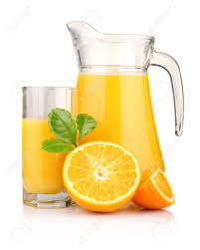
0.70 each
1.5 litre Bottled Water Still or Sparkling
£1.50 each

